**Hand washing Fiasco Scenario**

**Directions: Highlight each situation where hand washing should take place.**

Marcus came into the child care center. While his mom was signing him in, he wiped his nose across his hand and sleeve, sat down at the play dough table and started rolling out snakes. Everyone else had already eaten breakfast, but Teacher Leah had saved some for him. As she finished diapering Juanita, she reached over and got his plate from the counter and put it on the table. “Here, Marcus,” she said. “Come, have your breakfast.” It was French toast, his favorite, and he hurried over, sat down and began to eat. “Mmm,” said Marcus, as his nose began to run again and he coughed. Teacher Leah grabbed a tissue and wiped Marcus’ nose. Just then, Alysia needed help putting on the paint apron, so Teacher Leah helped her with the apron. Part of the class had been outside and they now came in, clustered around Cameron, who had found a worm. Teacher Mark helped Cameron put it into the terrarium and they all gathered for circle time. Teacher Leah started reading the children a story. Half way through the story, Isaiah said that he didn’t feel well. Teacher Mark felt his forehead and thought that Isaiah might be a bit warm. He took Isaiah to the office. When he returned, he sat down at circle, put his arm around Adison, and listened to the rest of the story.

**Hand washing Fiasco Scenario**

**Teacher’s Key**

**Directions: Highlight each situation where hand washing should take place.**

Marcus came into the child care center. While his mom was signing him in, he wiped his nose across his hand and sleeve, sat down at the play dough table and started rolling out snakes. Everyone else had already eaten breakfast, but Teacher Leah had saved some for him. As she finished diapering Juanita, she reached over and got his plate from the counter and put it on the table. “Here, Marcus,” she said. “Come, have your breakfast.” It was French toast, his favorite, and he hurried over, sat down and began to eat. “Mmm,” said Marcus, as his nose began to run again and he coughed. Teacher Leah grabbed a tissue and wiped Marcus’ nose. Just then, Alysia needed help putting on the paint apron, so Teacher Leah helped her with the apron. Part of the class had been outside and they now came in, clustered around Cameron, who had found a worm. Teacher Mark helped Cameron put it into the terrarium and they all gathered for circle time. Teacher Leah started reading the children a story. Half way through the story, Isaiah said that he didn’t feel well. Teacher Mark felt his forehead and thought that Isaiah might be a bit warm. He took Isaiah to the office. When he returned, he sat down at circle, put his arm around Addison, and listened to the rest of the story.

***Hand washing Tips***

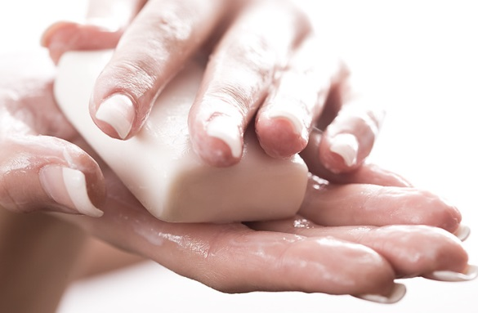

* Check to be sure a paper towel is available.
* Turn on water to a comfortable temperature.
* Moisten hands with water and apply heavy lather of liquid soap.
* Wash well under running water for at least 10 seconds.
* Pay particular attention to areas between fingers, around nail beds, under fingernails, and back of hands.
* Rinse well under running water until free of soap and dirt. Hold hands so that water flows from wrist to fingertips.
* Dry hands with paper towels.
* Use paper towel to turn off faucet; then discard towel.
* Use hand lotion, if desired.

